LangGraph + SQLite
We were inmemory saver to save context in the RAM or memory before but this has an disadvantage that if we reload the page, the entire chat history is gone.
There are 3 Common Checkpoint Savers in LangGraph :-
1. MemorySaver / InMemorySaver — Stores conversation/state in RAM. Fast and simple, but data is lost when the application stops.
2. SqliteSaver — Stores state in a SQLite file/database. Data persists after restarting the application and is convenient for local projects.
3. PostgresSaver — Stores state in PostgreSQL. Persistent and designed for larger, multi-user production applications.

We used InMemorySaver up until now but now we will use SqliteSaver.

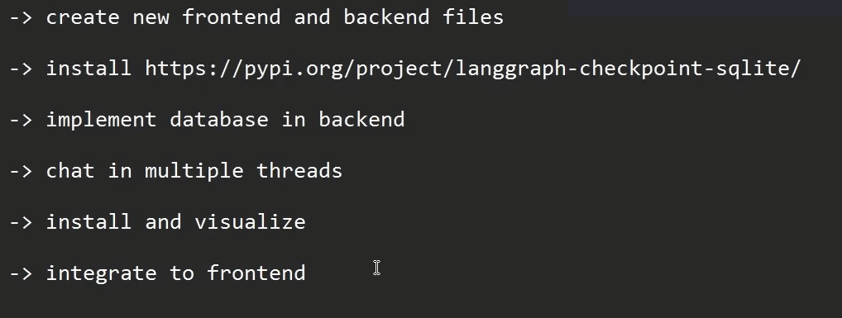

We will make a few changes in the previous backend file and some changes in the front file and that’s all.

BackEnd Code:-
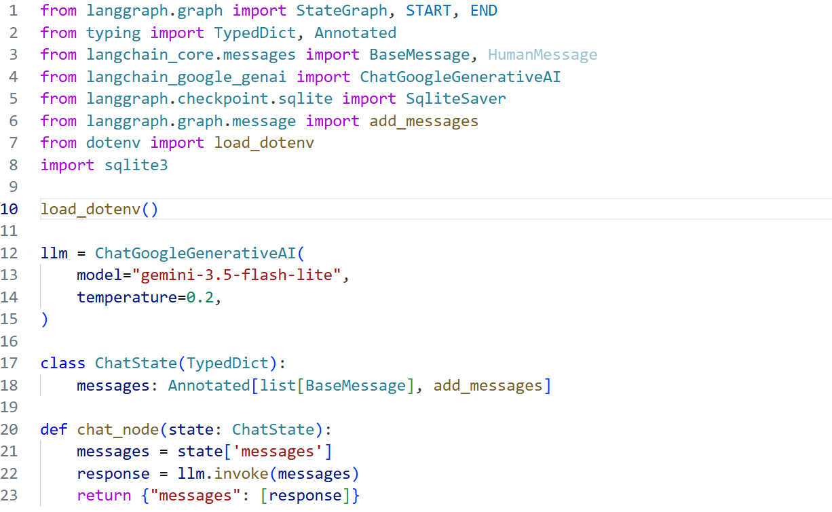
sqlite3.connect() creates a connection to the SQLite database named chatbot.db.
SqliteSaver then uses this SQLite connection as LangGraph's checkpoint storage, allowing LangGraph to save and retrieve conversation states.
check_same_thread=False - By setting it to False, we are saying that the same SQLite database connection can be used from different threads. If it were True, the connection could only be used by the thread that created it. Another thread trying to use that connection would cause an error.
This function retrieves all unique conversation/thread IDs stored in the checkpointer.
- checkpointer.list(None) → gets all saved checkpoints.
- checkpoint.config[...] → extracts the thread_id.
- set() → removes duplicate thread IDs.
- list(all_threads) → returns all unique thread IDs as a list.
None means no filter is being applied.
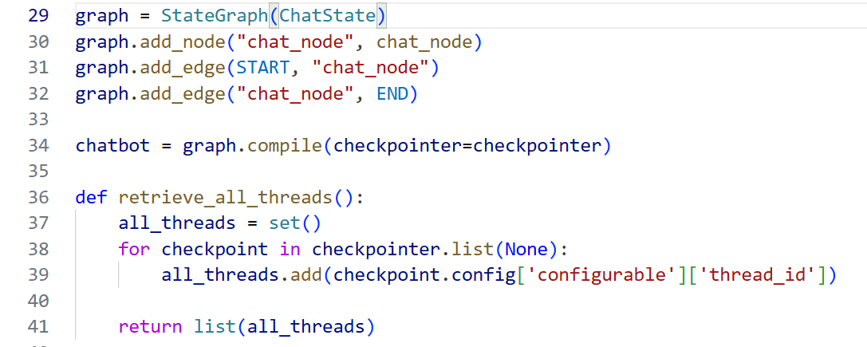

FrontEnd Code:- Here we are importing chatbbot and retrieve_all_threads from backend.
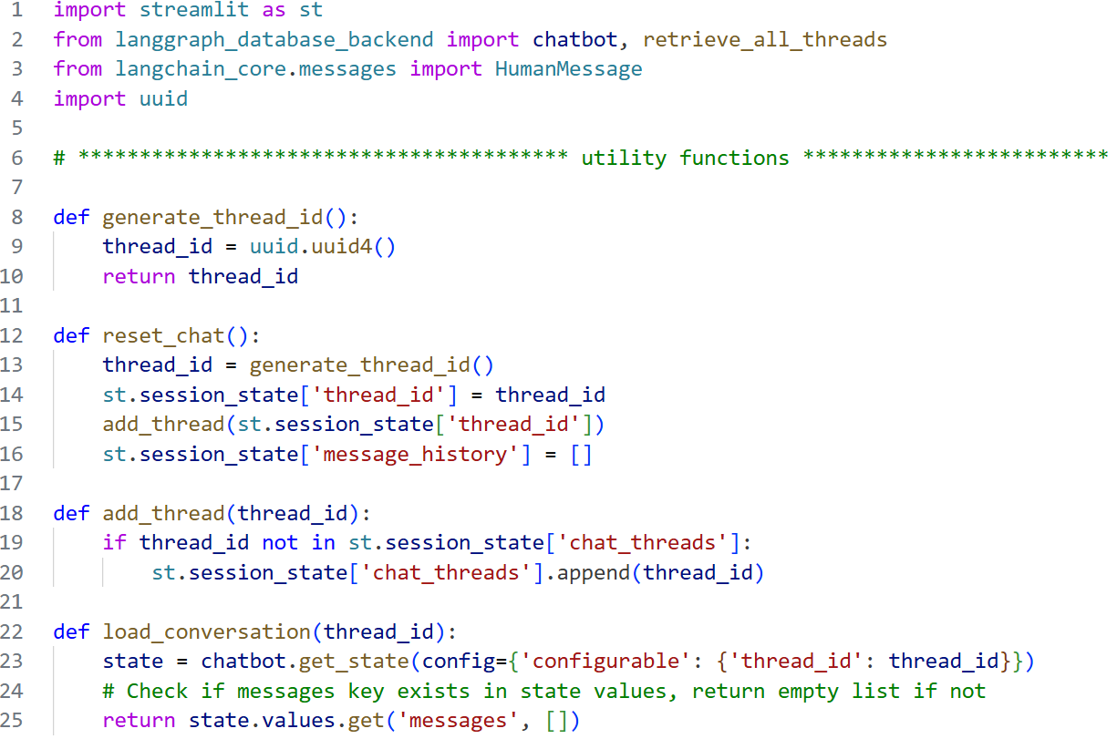

Previously, we initialized chat_threads as an empty list in session_state. Now, instead, we call retrieve_all_threads() from the backend to retrieve all previously saved thread IDs from the SQLite database.
This means that even after restarting the Streamlit application, the previously created conversations can still be retrieved.
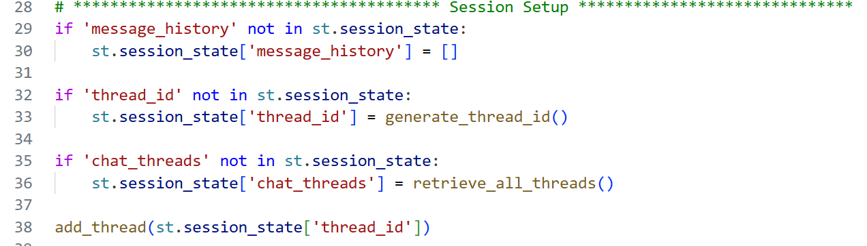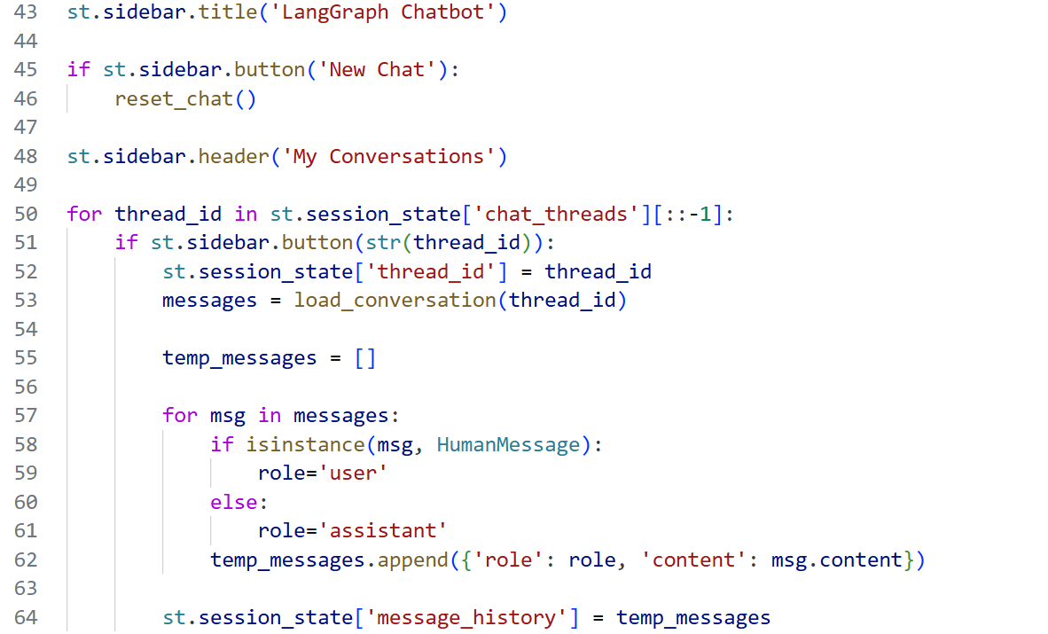
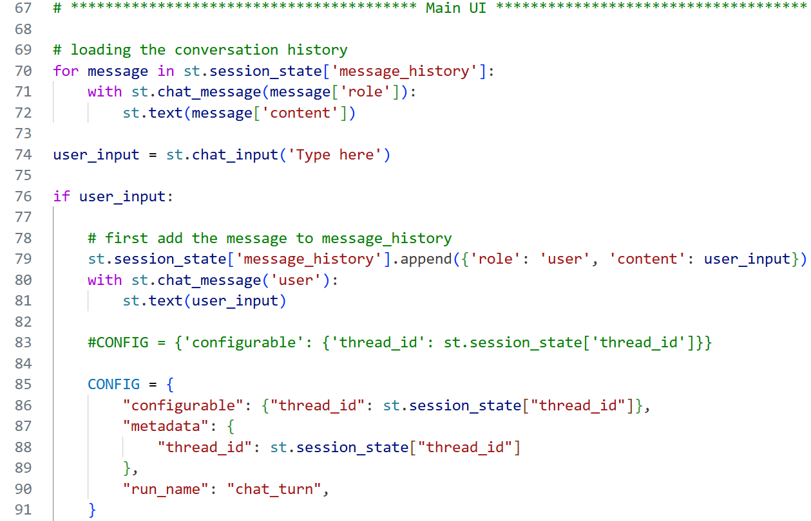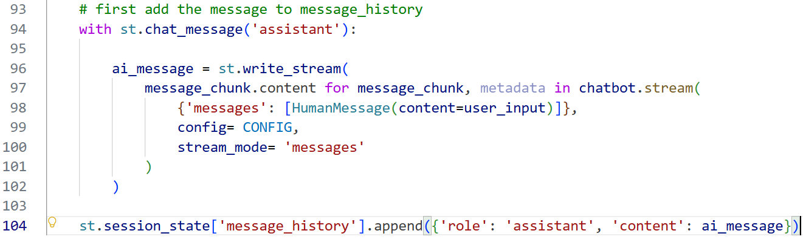
There no change apart from those changes on top in this code.

